

Practical No.: 8
Aim –
To access and validate form fields using JavaScript events and design a Gym Admission Registration Form with live input validation.
Software/Tools Required –
- VSCode
- Chrome
- HTML5
- CSS3
- Javascript (ES6)
Experiment Program Code –
index.html

<!DOCTYPE html>
<html lang="en">
<head>
<meta charset="UTF-8">
<meta name="viewport" content="width=device-width, initial-scale=1.0">
<title>FITPASS - Gym Admission</title>

<style>
*{
margin:0;
padding:0;
box-sizing:border-box;
}

body{
font-family:Arial,Helvetica,sans-serif;
min-height:100vh;
background:#f4f5f6;
color:#17191b;
overflow-x:hidden;
}

.background{
position:fixed;
inset:0;
overflow:hidden;
z-index:0;
background:
radial-gradient(circle at 15% 25%,rgba(230,57,70,.13),transparent 25%),
radial-gradient(circle at 90% 75%,rgba(230,57,70,.10),transparent 28%),
linear-gradient(135deg,#ffffff 0%,#f3f4f5 100%);
}

.background:before{
content:"";
position:absolute;
width:700px;
height:700px;
right:-300px;
top:-300px;
border-radius:50%;
border:90px solid rgba(230,57,70,.035);
box-shadow:
0 0 0 70px rgba(230,57,70,.025),
0 0 0 140px rgba(230,57,70,.018);
}

.background:after{
content:"";
position:absolute;
width:550px;
height:550px;
left:-300px;
bottom:-300px;
border-radius:50%;
border:80px solid rgba(0,0,0,.025);
box-shadow:
0 0 0 60px rgba(0,0,0,.015);
}

.light{
position:absolute;
border-radius:50%;
filter:blur(70px);
background:rgba(230,57,70,.08);
animation:lightMove 9s ease-in-out infinite alternate;
}

.light.one{
width:380px;
height:380px;
left:-150px;
top:15%;
}

.light.two{
width:320px;
height:320px;
right:-130px;
bottom:8%;
animation-delay:3s;
}

@keyframes lightMove{
from{
transform:translate(0,0);
}
to{
transform:translate(70px,40px) scale(1.15);
}
}

.equipment{
position:absolute;
opacity:.15;
z-index:1;
filter:drop-shadow(0 18px 15px rgba(0,0,0,.16));
animation:float 6s ease-in-out infinite;
}

.dumbbell{
width:190px;
height:70px;
}

.dumbbell .bar{
position:absolute;
width:115px;
height:14px;
left:38px;
top:28px;
border-radius:20px;
background:linear-gradient(
90deg,
#666,
#eee,
#777,
#fff,
#666
);
}

.dumbbell .plate{
position:absolute;
width:40px;
height:56px;
top:7px;
border-radius:8px;
background:linear-gradient(
145deg,
#d4d6d8,
#626669,
#b7babc
);
box-shadow:
inset 5px 5px 8px rgba(255,255,255,.5),
inset -5px -5px 8px rgba(0,0,0,.2);
}

.dumbbell .left{
left:0;
}

.dumbbell .right{
right:0;
}

.dumbbell.one{
left:3%;
top:22%;
transform:rotate(-25deg);
}

.dumbbell.two{
right:3%;
bottom:19%;
transform:rotate(25deg) scale(.85);
animation-delay:2s;
}

.plate3d{
width:150px;
height:150px;
border-radius:50%;
border:28px solid #a5a9ab;
background:#d6d8da;
box-shadow:
inset 0 0 0 8px #eee,
inset 0 0 0 16px #85898c,
0 22px 30px rgba(0,0,0,.16);
}

.plate3d:before{
content:"";
position:absolute;
width:43px;
height:43px;
left:25px;
top:25px;
border-radius:50%;
background:#f5f5f5;
border:8px solid #777b7e;
}

.plate3d:after{
content:"FIT";
position:absolute;
left:45px;
top:79px;
font-size:12px;
font-weight:bold;
letter-spacing:3px;
color:#73777a;
}

.plate3d.one{
right:5%;
top:16%;
animation-delay:1s;
}

.plate3d.two{
left:4%;
bottom:7%;
transform:scale(.55);
animation-delay:4s;
}

.kettle{
width:100px;
height:90px;
border-radius:48% 48% 35% 35%;
background:linear-gradient(
145deg,
#d6d8da,
#6d7174,
#babdc0
);
box-shadow:
inset 8px 8px 12px rgba(255,255,255,.7),
inset -10px -10px 15px rgba(0,0,0,.2),
0 20px 25px rgba(0,0,0,.15);
}

.kettle:before{
content:"";
position:absolute;
width:65px;
height:52px;
left:18px;
top:-35px;
border:13px solid #85898c;
border-bottom:0;
border-radius:40px 40px 0 0;
}

.kettle:after{
content:"";
position:absolute;
width:22px;
height:22px;
left:39px;
top:35px;
border-radius:50%;
background:#f5f5f5;
border:4px solid #777b7e;
}

.kettle.one{
left:16%;
top:12%;
transform:scale(.65);
animation-delay:1s;
}

.kettle.two{
right:17%;
bottom:10%;
transform:scale(.6);
animation-delay:4s;
}

.barbell{
width:310px;
height:80px;
right:-50px;
top:69%;
transform:rotate(-13deg);
animation-delay:2s;
}

.barbell .rod{
position:absolute;
width:260px;
height:13px;
left:25px;
top:35px;
border-radius:20px;
background:linear-gradient(
90deg,
#666,
#eee,
#777,
#fff,
#666
);
}

.barbell .disc{
position:absolute;
width:36px;
height:62px;
top:10px;
border-radius:7px;
background:linear-gradient(
145deg,
#c2c5c7,
#65696c,
#b5b8ba
);
box-shadow:
inset 5px 5px 8px rgba(255,255,255,.5),
inset -5px -5px 8px rgba(0,0,0,.2);
}

.barbell .d1{
left:0;
}

.barbell .d2{
left:39px;
height:72px;
top:5px;
}

.barbell .d3{
right:39px;
height:72px;
top:5px;
}

.barbell .d4{
right:0;
}

@keyframes float{
0%,100%{
translate:0 0;
}
50%{
translate:0 -22px;
}
}

.dot{
position:absolute;
width:5px;
height:5px;
border-radius:50%;
background:#e63946;
opacity:.3;
animation:particle 6s linear infinite;
}

.dot.a{
left:20%;
bottom:15%;
}

.dot.b{
left:75%;
bottom:25%;
animation-delay:2s;
}

.dot.c{
left:85%;
top:35%;
animation-delay:3s;
}

@keyframes particle{
0%{
opacity:0;
transform:translateY(20px);
}
30%{
opacity:.4;
}
100%{
opacity:0;
transform:translateY(-160px);
}
}

header{
position:relative;
z-index:20;
height:82px;
display:flex;
align-items:center;
padding:0 7%;
background:white;
border-bottom:1px solid #e5e5e5;
box-shadow:0 4px 18px rgba(0,0,0,.07);
}

.logo{
display:flex;
align-items:center;
gap:10px;
}

.logo-icon{
position:relative;
width:48px;
height:42px;
}

.logo-bar{
position:absolute;
width:42px;
height:7px;
left:3px;
top:3px;
background:#151b24;
border-radius:3px;
}

.logo-bar:before,
.logo-bar:after{
content:"";
position:absolute;
width:4px;
height:16px;
top:-5px;
background:#151b24;
border-radius:2px;
}

.logo-bar:before{
left:7px;
}

.logo-bar:after{
right:7px;
}

.logo-pin{
position:absolute;
width:30px;
height:30px;
left:9px;
top:10px;
background:#e63946;
clip-path:polygon(
0 0,
100% 0,
50% 100%
);
}

.logo-pin:before{
content:"";
position:absolute;
width:13px;
height:13px;
left:8.5px;
top:4px;
border-radius:50%;
background:white;
}

.logo-text{
font-size:43px;
letter-spacing:5px;
font-weight:500;
color:#151b24;
}

.logo-text .fit{
color:#e63946;
font-weight:600;
}

.logo-text .pass{
color:#151b24;
font-weight:600;
}

.register{
font-size:13px;
vertical-align:top;
margin-left:-2px;
}

main{
position:relative;
z-index:10;
min-height:calc(100vh - 82px);
display:flex;
justify-content:center;
align-items:center;
padding:35px 20px 70px;
}

.wrapper{
width:100%;
max-width:465px;
}

.intro{
text-align:center;
margin-bottom:20px;
}

.badge{
display:inline-flex;
align-items:center;
gap:7px;
padding:7px 14px;
background:white;
border:1px solid #efc6ca;
border-radius:30px;
color:#d52d3a;
font-size:10px;
font-weight:bold;
letter-spacing:1px;
text-transform:uppercase;
box-shadow:0 5px 15px rgba(0,0,0,.05);
}

.badge i{
width:6px;
height:6px;
background:#e63946;
border-radius:50%;
}

.intro h1{
margin-top:12px;
font-size:37px;
line-height:1.05;
letter-spacing:-1.5px;
}

.intro h1 span{
color:#e63946;
}

.intro p{
margin-top:8px;
color:#777c80;
font-size:13px;
}

.card{
position:relative;
background:rgba(255,255,255,.98);
border:1px solid #e1e3e5;
border-radius:22px;
padding:30px;
box-shadow:
0 25px 65px rgba(0,0,0,.12),
0 5px 18px rgba(0,0,0,.04);
animation:cardIn .7s ease;
}

.card:before{
content:"";
position:absolute;
top:0;
left:35px;
right:35px;
height:3px;
border-radius:0 0 10px 10px;
background:linear-gradient(
90deg,
transparent,
#e63946,
transparent
);
}

@keyframes cardIn{
from{
opacity:0;
transform:translateY(25px);
}
to{
opacity:1;
transform:translateY(0);
}
}

.card-head{
display:flex;
justify-content:space-between;
align-items:center;
margin-bottom:18px;
}

.card-head h2{
font-size:19px;
}

.card-head small{
color:#9a9ea1;
font-size:10px;
letter-spacing:1px;
}

label{
display:block;
margin:13px 0 6px;
font-size:12px;
font-weight:bold;
color:#3c4043;
}

input,
select{
width:100%;
height:44px;
padding:0 13px;
border:1px solid #dfe1e3;
border-radius:9px;
background:#f9fafb;
outline:none;
font-size:13px;
color:#222;
transition:.25s;
}

input::placeholder{
color:#a1a5a8;
}

input:hover,
select:hover{
background:white;
border-color:#c7cacc;
}

input:focus,
select:focus{
background:white;
border-color:#e63946;
box-shadow:0 0 0 3px rgba(230,57,70,.08);
}

select{
cursor:pointer;
}

.error{
display:block;
min-height:14px;
margin-top:3px;
font-size:10px;
color:#e63946;
}

button{
width:100%;
height:48px;
margin-top:16px;
border:0;
border-radius:9px;
background:linear-gradient(
135deg,
#ed3d49,
#d32634
);
color:white;
font-size:12px;
font-weight:bold;
letter-spacing:1px;
cursor:pointer;
box-shadow:0 10px 22px rgba(230,57,70,.22);
transition:.3s;
}

button:hover{
transform:translateY(-2px);
box-shadow:0 15px 30px rgba(230,57,70,.30);
}

button:active{
transform:scale(.98);
}

.success{
min-height:16px;
margin-top:12px;
text-align:center;
color:#159447;
font-size:12px;
font-weight:bold;
}

footer{
position:fixed;
bottom:11px;
left:0;
width:100%;
text-align:center;
z-index:30;
}

footer span{
font-size:11px;
color:#999ea1;
letter-spacing:.5px;
}

footer strong{
color:#4d5255;
}

@media(max-width:600px){

header{
height:70px;
justify-content:center;
padding:0;
}

.logo-text{
font-size:35px;
}

.logo-icon{
transform:scale(.85);
}

main{
min-height:calc(100vh - 70px);
padding:25px 15px 60px;
align-items:flex-start;
}

.intro h1{
font-size:29px;
}

.intro p{
font-size:12px;
}

.card{
padding:23px 20px;
border-radius:18px;
}

.equipment{
opacity:.07;
}

footer{
bottom:7px;
}
}
</style>
</head>

<body>

<div class="background">

<div class="light one"></div>
<div class="light two"></div>

<div class="equipment dumbbell one">
<div class="bar"></div>
<div class="plate left"></div>
<div class="plate right"></div>
</div>

<div class="equipment dumbbell two">
<div class="bar"></div>
<div class="plate left"></div>
<div class="plate right"></div>
</div>

<div class="equipment plate3d one"></div>
<div class="equipment plate3d two"></div>

<div class="equipment kettle one"></div>
<div class="equipment kettle two"></div>

<div class="equipment barbell">
<div class="rod"></div>
<div class="disc d1"></div>
<div class="disc d2"></div>
<div class="disc d3"></div>
<div class="disc d4"></div>
</div>

<div class="dot a"></div>
<div class="dot b"></div>
<div class="dot c"></div>

</div>

<header>

<div class="logo">

<div class="logo-icon">

<div class="logo-bar"></div>
<div class="logo-pin"></div>

</div>

<div class="logo-text">
<span class="fit">FIT</span><span class="pass">PASS</span><sup class="register">®</sup>
</div>

</div>

</header>

<main>

<div class="wrapper">

<div class="intro">

<div class="badge">
<i></i>
Premium Fitness Membership
</div>

<h1>
Build Your <span>Best</span><br>
Version
</h1>

<p>
Take the first step towards a stronger, healthier you.
</p>

</div>

<div class="card">

<div class="card-head">

<h2>Gym Admission</h2>

<small>01 / JOIN</small>

</div>

<form id="gymForm">

<label>Full Name</label>

<input
type="text"
id="name"
placeholder="Enter your full name"
>

<span id="nameError" class="error"></span>

<label>Age</label>

<input
type="number"
id="age"
placeholder="Enter your age"
>

<span id="ageError" class="error"></span>

<label>Email Address</label>

<input
type="email"
id="email"
placeholder="Enter your email"
>

<span id="emailError" class="error"></span>

<label>Mobile Number</label>

<input
type="text"
id="mobile"
placeholder="Enter 10-digit mobile number"
maxlength="10"
>

<span id="mobileError" class="error"></span>

<label>Membership Plan</label>

<select id="plan">

<option value="">Select your plan</option>
<option value="Monthly">Monthly</option>
<option value="Quarterly">Quarterly</option>
<option value="Yearly">Yearly</option>

</select>

<span id="planError" class="error"></span>

<button type="submit">
JOIN FITPASS
</button>

<p id="result" class="success"></p>

</form>

</div>

</div>

</main>

<footer>

<span>
Designed & Developed by
<strong>Salim Ansari</strong>
</span>

</footer>

<script>

document.getElementById("name").addEventListener("input",function(){

let value=this.value;

if(value==="" || /^[A-Za-z ]+$/.test(value)){
document.getElementById("nameError").innerHTML="";
}
else{
document.getElementById("nameError").innerHTML=
"Only letters allowed.";
}

});

document.getElementById("age").addEventListener("blur",function(){

let age=this.value;

if(age>=16 && age<=60){
document.getElementById("ageError").innerHTML="";
}
else{
document.getElementById("ageError").innerHTML=
"Age must be between 16 and 60.";
}

});

document.getElementById("email").addEventListener("input",function(){

let email=this.value;

let pattern=/^[^\s@]+@[^\s@]+\.[^\s@]+$/;

if(email==="" || pattern.test(email)){
document.getElementById("emailError").innerHTML="";
}
else{
document.getElementById("emailError").innerHTML=
"Invalid email.";
}

});

document.getElementById("mobile").addEventListener("input",function(){

let mobile=this.value;

if(/^\d{10}$/.test(mobile)){
document.getElementById("mobileError").innerHTML="";
}
else{
document.getElementById("mobileError").innerHTML=
"Enter 10-digit mobile number.";
}

});

document.getElementById("plan").addEventListener("change",function(){

if(this.value===""){
document.getElementById("planError").innerHTML=
"Please select a plan.";
}
else{
document.getElementById("planError").innerHTML="";
}

});

document.getElementById("gymForm").addEventListener("submit",function(e){

e.preventDefault();

let name=document.getElementById("name").value.trim();
let age=document.getElementById("age").value;
let email=document.getElementById("email").value.trim();
let mobile=document.getElementById("mobile").value;
let plan=document.getElementById("plan").value;

let valid=true;

if(!/^[A-Za-z ]+$/.test(name)){
document.getElementById("nameError").innerHTML=
"Please enter a valid name.";
valid=false;
}

if(!(age>=16 && age<=60)){
document.getElementById("ageError").innerHTML=
"Age must be between 16 and 60.";
valid=false;
}

if(!/^[^\s@]+@[^\s@]+\.[^\s@]+$/.test(email)){
document.getElementById("emailError").innerHTML=
"Invalid email.";
valid=false;
}

if(!/^\d{10}$/.test(mobile)){
document.getElementById("mobileError").innerHTML=
"Enter 10-digit mobile number.";
valid=false;
}

if(plan===""){
document.getElementById("planError").innerHTML=
"Please select a plan.";
valid=false;
}

if(valid){

document.getElementById("result").innerHTML=
"✓ Gym Admission Successful!";

}
else{

document.getElementById("result").innerHTML="";

}

});

</script>

</body>
</html>

Output –
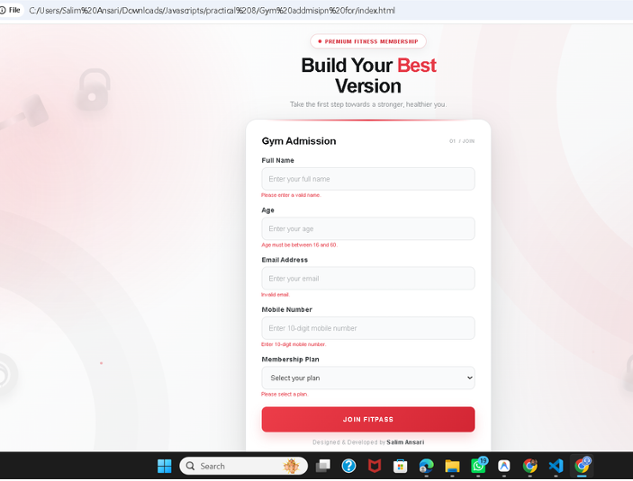

Case Study Title –
Gym Admission Registration Form Design a Gym Admission Registration Form using HTML, CSS and JavaScript. The form should collect basic information from a person who wants to register for gym admission. The form should contain:
Case Study Program Code –
index.html
<!DOCTYPE html>
<html lang="en">
<head>
<meta charset="UTF-8" />
<meta name="viewport" content="width=device-width, initial-scale=1.0" />
<title>FITKID // Junior & Youth Fitness Academy</title>

<link rel="preconnect" href="https://fonts.googleapis.com">
<link rel="preconnect" href="https://fonts.gstatic.com" crossorigin>
<link href="https://fonts.googleapis.com/css2?family=Plus+Jakarta+Sans:wght@400;500;600;700;800&family=Cabinet+Grotesk:wght@800;900&display=swap" rel="stylesheet">

<style>
:root {
--primary: #ff5722;
--primary-glow: rgba(255, 87, 34, 0.4);
--bg-dark: #0d1117;
--light-bg: #ffffff;
--input-bg: #f4f5f8;
--text-dark: #111827;
--text-muted: #848d9c;
}

* {
margin: 0;
padding: 0;
box-sizing: border-box;
font-family: 'Plus Jakarta Sans', sans-serif;
}

body {
background: var(--bg-dark);
min-height: 100vh;
display: flex;
justify-content: center;
align-items: center;
}

.split-layout {
width: 100vw;
min-height: 100vh;
display: grid;
grid-template-columns: 46% 54%;
background: var(--light-bg);
}

.left-zone {
background: radial-gradient(circle at 50% 65%, #1f1a2e 0%, var(--bg-dark) 75%);
display: flex;
flex-direction: column;
justify-content: space-between;
padding: 50px 65px;
position: relative;
overflow: hidden;
border-right: 1px solid rgba(255, 255, 255, 0.05);
}

.brand-pill {
display: flex;
align-items: center;
gap: 12px;
z-index: 5;
}

.brand-icon {
background: linear-gradient(135deg, #ff5722, #ff8a65);
color: #ffffff;
font-weight: 800;
font-size: 0.95rem;
padding: 6px 10px;
border-radius: 8px;
box-shadow: 0 4px 15px var(--primary-glow);
}

.brand-name {
color: #ffffff;
font-weight: 800;
letter-spacing: 2px;
font-size: 1.1rem;
}

.hero-info {
margin-top: 30px;
z-index: 5;
}

.hero-tag {
font-size: 0.72rem;
letter-spacing: 2px;
color: #94a3b8;
text-transform: uppercase;
font-weight: 700;
margin-bottom: 8px;
}

.hero-title {
font-family: 'Cabinet Grotesk', sans-serif;
font-size: 3.6rem;
line-height: 0.95;
font-weight: 900;
color: #ffffff;
}

.hero-title span {
color: var(--primary);
}

.hero-desc {
margin-top: 16px;
color: #94a3b8;
font-size: 0.95rem;
line-height: 1.5;
max-width: 360px;
}

.character-stage {
position: relative;
height: 270px;
display: flex;
align-items: center;
justify-content: center;
margin: 15px 0;
}

.stage-glow {
position: absolute;
width: 250px;
height: 250px;
background: radial-gradient(circle, rgba(255, 87, 34, 0.25) 0%, rgba(99, 102, 241, 0.1) 50%, transparent 70%);
border-radius: 50%;
animation: auraBreathe 3s ease-in-out infinite alternate;
}

.boy-svg {
width: 220px;
height: 240px;
z-index: 2;
animation: boyBounce 1.2s ease-in-out infinite alternate;
transform-origin: bottom center;
}

.arm-left {
transform-origin: 88px 105px;
animation: waveArmLeft 1.2s cubic-bezier(0.45, 0.05, 0.55, 0.95) infinite alternate;
}

.arm-right {
transform-origin: 132px 105px;
animation: waveArmRight 1.2s cubic-bezier(0.45, 0.05, 0.55, 0.95) infinite alternate;
}

.kid-eyes {
animation: eyeBlink 3.5s infinite;
transform-origin: center;
}

.leg-left {
transform-origin: 98px 170px;
animation: stepLegLeft 1.2s ease-in-out infinite alternate;
}

.leg-right {
transform-origin: 122px 170px;
animation: stepLegRight 1.2s ease-in-out infinite alternate;
}

@keyframes boyBounce {
0% {
transform: translateY(8px);
}
100% {
transform: translateY(-16px);
}
}

@keyframes waveArmLeft {
0% {
transform: rotate(-15deg);
}
100% {
transform: rotate(-95deg);
}
}

@keyframes waveArmRight {
0% {
transform: rotate(15deg);
}
100% {
transform: rotate(95deg);
}
}

@keyframes stepLegLeft {
0% {
transform: scaleY(0.95);
}
100% {
transform: scaleY(1.05);
}
}

@keyframes stepLegRight {
0% {
transform: scaleY(1.05);
}
100% {
transform: scaleY(0.95);
}
}

@keyframes eyeBlink {
0%, 90%, 100% {
transform: scaleY(1);
}
95% {
transform: scaleY(0.1);
}
}

@keyframes auraBreathe {
0% {
transform: scale(0.85);
opacity: 0.5;
}
100% {
transform: scale(1.15);
opacity: 0.9;
}
}

.steps-strip {
display: flex;
gap: 36px;
border-top: 1px solid rgba(255, 255, 255, 0.08);
padding-top: 22px;
z-index: 5;
}

.step-box .s-num {
font-size: 1.1rem;
font-weight: 800;
color: var(--primary);
display: block;
}

.step-box .s-text {
font-size: 0.65rem;
letter-spacing: 1.5px;
color: #64748b;
font-weight: 700;
text-transform: uppercase;
margin-top: 2px;
}

.right-zone {
padding: 55px 75px;
display: flex;
flex-direction: column;
justify-content: center;
position: relative;
overflow-y: auto;
}

.corner-badge {
position: absolute;
top: 30px;
right: 50px;
font-family: 'Cabinet Grotesk', sans-serif;
font-size: 6.2rem;
font-weight: 900;
color: #f1f3f7;
user-select: none;
line-height: 1;
z-index: 0;
}

.form-wrapper {
position: relative;
z-index: 2;
max-width: 540px;
width: 100%;
}

.badge-sub {
font-size: 0.72rem;
letter-spacing: 1.6px;
color: var(--primary);
font-weight: 800;
text-transform: uppercase;
margin-bottom: 6px;
}

.title-main {
font-size: 2.2rem;
font-weight: 800;
color: var(--text-dark);
letter-spacing: -0.5px;
margin-bottom: 4px;
}

.title-sub {
color: var(--text-muted);
font-size: 0.95rem;
margin-bottom: 26px;
}

.form-content {
display: flex;
flex-direction: column;
gap: 20px;
}

.field-wrap {
display: flex;
flex-direction: column;
gap: 7px;
}

.dual-row {
display: grid;
grid-template-columns: 1fr 1fr;
gap: 20px;
}

label {
font-size: 0.85rem;
font-weight: 700;
color: #1f2937;
}

.ast {
color: var(--primary);
margin-left: 2px;
}

.form-input {
background: var(--input-bg);
border: 1px solid transparent;
border-radius: 9px;
padding: 13px 16px;
font-size: 0.92rem;
color: var(--text-dark);
outline: none;
transition: all 0.25s ease;
}

.form-input::placeholder {
color: #9ca3af;
}

.form-input:focus {
background: #ffffff;
border-color: #cbd5e1;
box-shadow: 0 0 0 4px rgba(255, 87, 34, 0.12);
}

.radio-choices {
display: flex;
align-items: center;
gap: 24px;
height: 48px;
}

.radio-tag {
display: flex;
align-items: center;
gap: 8px;
font-size: 0.92rem;
font-weight: 500;
color: #374151;
cursor: pointer;
}

input[type="radio"], input[type="checkbox"] {
accent-color: var(--primary);
width: 17px;
height: 17px;
cursor: pointer;
}

.checkbox-deck {
display: grid;
grid-template-columns: 1fr 1fr;
gap: 14px;
}

.check-plate {
display: flex;
align-items: center;
gap: 10px;
background: var(--input-bg);
padding: 13px 16px;
border-radius: 9px;
cursor: pointer;
font-size: 0.88rem;
font-weight: 500;
color: #374151;
transition: all 0.2s;
}

.check-plate:hover {
background: #e9ecf2;
}

textarea.form-input {
resize: vertical;
min-height: 100px;
}

.char-status {
text-align: right;
font-size: 0.74rem;
color: #9ca3af;
margin-top: 4px;
}

.actions-bar {
display: flex;
justify-content: flex-end;
align-items: center;
gap: 12px;
margin-top: 6px;
}

.btn-reset {
background: #f1f3f7;
color: #4b5563;
border: none;
padding: 12px 22px;
border-radius: 8px;
font-size: 0.9rem;
font-weight: 600;
cursor: pointer;
transition: all 0.2s;
}

.btn-reset:hover {
background: #e5e7eb;
}

.btn-submit-action {
background: #ea8b75;
color: #ffffff;
border: none;
padding: 12px 26px;
border-radius: 8px;
font-size: 0.9rem;
font-weight: 600;
cursor: pointer;
transition: all 0.25s;
}

.btn-submit-action:hover {
background: var(--primary);
transform: translateY(-2px);
box-shadow: 0 6px 20px var(--primary-glow);
}

.btn-submit-action:active {
transform: translateY(0);
}

.footer-stamp {
margin-top: 24px;
font-size: 0.72rem;
color: #9ca3af;
}

@media (max-width: 960px) {
.split-layout {
grid-template-columns: 1fr;
}
.left-zone, .right-zone {
padding: 40px 25px;
}
.dual-row, .checkbox-deck {
grid-template-columns: 1fr;
}
}
</style>
</head>
<body>

<div class="split-layout">

<div class="left-zone">
<div>
<div class="brand-pill">
<div class="brand-icon">FK</div>
<div class="brand-name">FITKID</div>
</div>

<div class="hero-info">
<div class="hero-tag">Active Kids • Stronger Future</div>
<h1 class="hero-title">
Play hard.<br>
<span>Grow stronger.</span>
</h1>
<p class="hero-desc">
Build agility, endurance, and confidence. Fill in the details to kickstart your child's fun athletic training.
</p>
</div>
</div>

<div class="character-stage">
<div class="stage-glow"></div>

<svg class="boy-svg" viewBox="0 0 220 240" fill="none" xmlns="http://www.w3.org/2000/svg">

<g class="arm-left">
<rect x="70" y="105" width="22" height="10" rx="5" fill="#fbc02d" />
<circle cx="68" cy="110" r="7" fill="#ffccbc" />
</g>

<g class="arm-right">
<rect x="128" y="105" width="22" height="10" rx="5" fill="#fbc02d" />
<circle cx="152" cy="110" r="7" fill="#ffccbc" />
</g>

<g class="leg-left">
<rect x="94" y="165" width="10" height="32" rx="5" fill="#1e293b" />
<path d="M88 195 C88 190 106 190 106 195 L106 200 L88 200 Z" fill="#ff5722" />
</g>
<g class="leg-right">
<rect x="116" y="165" width="10" height="32" rx="5" fill="#1e293b" />
<path d="M114 195 C114 190 132 190 132 195 L132 200 L114 200 Z" fill="#ff5722" />
</g>

<!-- Torso / T-Shirt -->
<rect x="86" y="102" width="48" height="66" rx="14" fill="#fbc02d" />
<!-- Star Graphic on Shirt -->
<circle cx="110" cy="130" r="7" fill="#ffffff" />

<!-- Head & Hair -->
<!-- Cute Hair Behind -->
<circle cx="110" cy="62" r="32" fill="#422006" />

<!-- Face -->
<circle cx="110" cy="66" r="27" fill="#ffccbc" />

<!-- Hair Bangs (Front) -->
<path d="M83 60 C90 40 130 40 137 60 C130 55 120 54 110 57 C100 54 90 55 83 60 Z" fill="#422006" />

<!-- Eyes with Live Blink -->
<g class="kid-eyes">
<ellipse cx="101" cy="66" rx="3.2" ry="4" fill="#0f172a" />
<ellipse cx="119" cy="66" rx="3.2" ry="4" fill="#0f172a" />
<!-- Eye sparkles -->
<circle cx="102" cy="64.5" r="1.2" fill="#ffffff" />
<circle cx="120" cy="64.5" r="1.2" fill="#ffffff" />
</g>

<!-- Cheerful Smile & Blush -->
<circle cx="94" cy="72" r="3.5" fill="#ff8a80" opacity="0.6" />
<circle cx="126" cy="72" r="3.5" fill="#ff8a80" opacity="0.6" />
<path d="M106 74 Q110 78 114 74" stroke="#d84315" stroke-width="2" stroke-linecap="round" fill="none" />
</svg>
</div>

<div class="steps-strip">
<div class="step-box">
<span class="s-num">01</span>
<span class="s-text">Register</span>
</div>
<div class="step-box">
<span class="s-num">02</span>
<span class="s-text">Train</span>
</div>
<div class="step-box">
<span class="s-num">03</span>
<span class="s-text">Transform</span>
</div>
</div>
</div>

<div class="right-zone">
<div class="corner-badge">08</div>

<div class="form-wrapper">
<div class="badge-sub">Membership Application</div>
<h2 class="title-main">Gym Admission Form</h2>
<p class="title-sub">Complete the form below to register.</p>

<form id="kidGymForm" novalidate onsubmit="validateGymForm(event)">
<div class="form-content">

<div class="field-wrap">
<label>Full Name <span class="ast">*</span></label>
<input type="text" id="fullName" class="form-input" placeholder="Enter your full name" required />
</div>

<div class="dual-row">
<div class="field-wrap">
<label>Sex <span class="ast">*</span></label>
<div class="radio-choices">
<label class="radio-tag">
<input type="radio" name="sex" value="Male" /> Male
</label>
<label class="radio-tag">
<input type="radio" name="sex" value="Female" /> Female
</label>
</div>
</div>

<div class="field-wrap">
<label>Eye Color <span class="ast">*</span></label>
<select id="eyeColor" class="form-input" required>
<option value="" disabled selected>Select eye color</option>
<option value="Brown">Brown</option>
<option value="Black">Black</option>
<option value="Blue">Blue</option>
<option value="Hazel">Hazel</option>
<option value="Green">Green</option>
</select>
</div>
</div>

<div class="field-wrap">
<label>Check all that apply</label>
<div class="checkbox-deck">
<label class="check-plate">
<input type="checkbox" name="attributes" value="Over 6 feet tall" />
<span>Over 6 feet tall</span>
</label>
<label class="check-plate">
<input type="checkbox" name="attributes" value="Over 200 pounds" />
<span>Over 200 pounds</span>
</label>
</div>
</div>

<div class="field-wrap">
<label>Describe your athletic ability <span class="ast">*</span></label>
<textarea id="ability" class="form-input" maxlength="300" placeholder="Tell us about your fitness or athletic experience..." required></textarea>
<div class="char-status"><span id="liveChars">0</span> / 300</div>
</div>

<div class="actions-bar">
<button type="button" class="btn-reset" onclick="resetForm()">Clear</button>
<button type="submit" class="btn-submit-action">
Enter My Information ↗
</button>
</div>

</div>
</form>

<div class="footer-stamp">
Design by Salim Ansari &nbsp;•&nbsp; 24070521005
</div>
</div>
</div>

</div>

<script>
const abilityField = document.getElementById('ability');
const liveChars = document.getElementById('liveChars');

abilityField.addEventListener('input', () => {
liveChars.textContent = abilityField.value.length;
});

function resetForm() {
document.getElementById('kidGymForm').reset();
liveChars.textContent = '0';
}

function validateGymForm(e) {
e.preventDefault();

const name = document.getElementById('fullName').value.trim();
const sex = document.querySelector('input[name="sex"]:checked');
const eyeColor = document.getElementById('eyeColor').value;
const ability = document.getElementById('ability').value.trim();

if (!name) {
alert("⚠️ Please enter Full Name.");
document.getElementById('fullName').focus();
return;
}

if (!sex) {
alert("⚠️ Please select your Sex (Male or Female).");
return;
}

if (!eyeColor) {
alert("⚠️ Please select your Eye Color.");
document.getElementById('eyeColor').focus();
return;
}

if (!ability) {
alert("⚠️ Please describe your Athletic Ability.");
document.getElementById('ability').focus();
return;
}

alert(`🎉 Welcome to FITKID, ${name}! Your admission form has been successfully submitted! 🚀`);
resetForm();
}
</script>
</body>
</html>

Output –

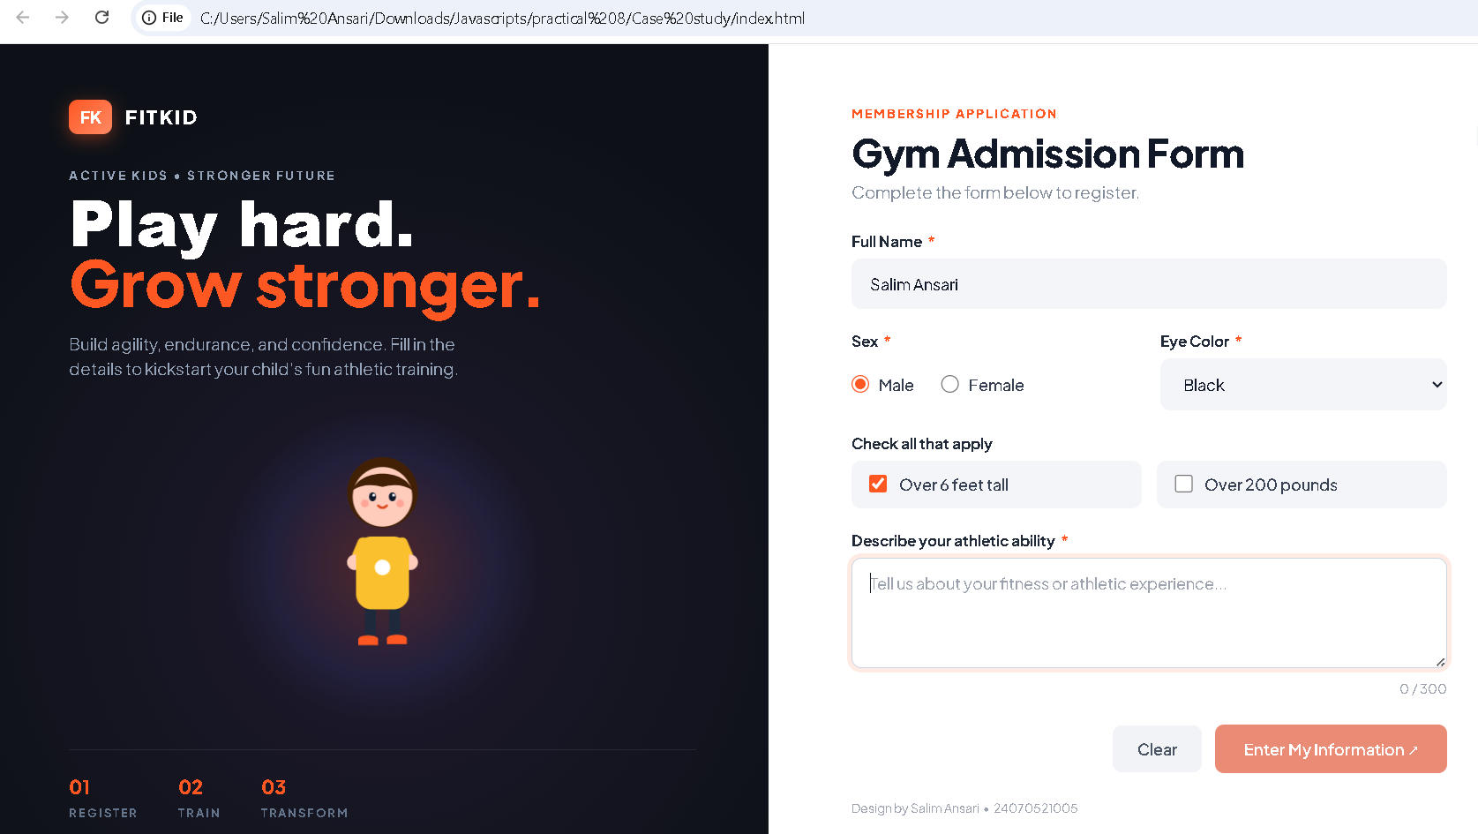
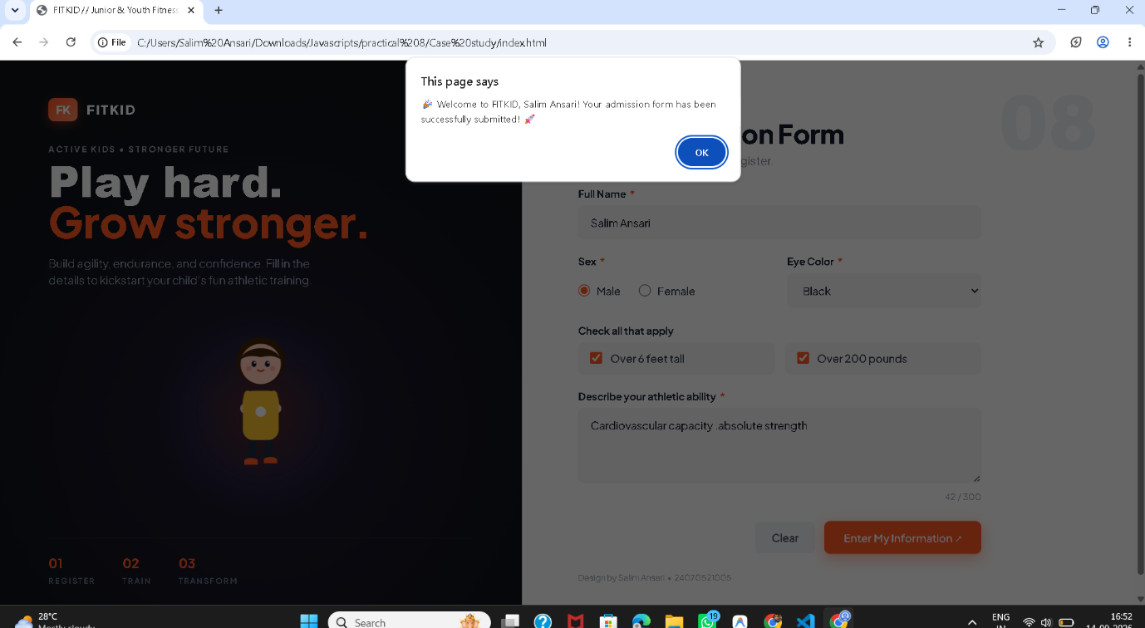

Conclusion –
In this experiment, a Gym Admission Registration Form was designed using HTML, CSS and JavaScript. Form fields were accessed and manipulated using the DOM. JavaScript events such as input, change, focus, blur and submit were used to perform live form validation. Invalid inputs were identified and appropriate messages were displayed to the user. The experiment demonstrated the practical use of JavaScript events and form validation for creating interactive web forms.

